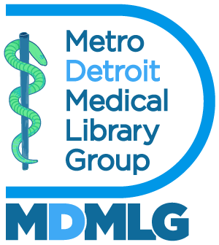

Executive Board Meeting June 17, 2026
Annual Report 2025 - 2026
Outreach Co-chair: Social Media Manager

Goals and Objectives

- To bring awareness of medical librarianship particularly to student members.
- To showcase events, professional development opportunities, celebrations etc. happening within the MDMLG community.
- To speak to the benefits of joining MDMLG.

Accomplishments

Over the past year, our membership has shown modest but steady growth. To support this momentum, I’ve highlighted our activities by sharing content from all social events and local conferences. Maintaining an active and welcoming social media presence has helped prospective members understand our mission, and see our community in action.

Metrics

Our Instagram account: @DetroitMedicalLibraryGroup has 55 followers and 255 posts. Our facebook group now has 20 followers and 140+ posts.

Respectfully submitted,

Michelle Rau
Social Media Manager

